EXCEL CURSORS

There are four different types of cursors in Excel. Understanding these cursors will make using Excel a lot easier. The cursor is the way your mouse looks on the screen.

SELECT

You can click to select one cell or click and drag to highlight many cells.

DRAG CELL

You will see this cursor when you put the mouse on the black line of a selected cell.

You can click and drag the whole cell to a different place on the sheet.

AUTO FILL

You will see this cursor when you put the mouse on the bottom-right corner of a selected cell.

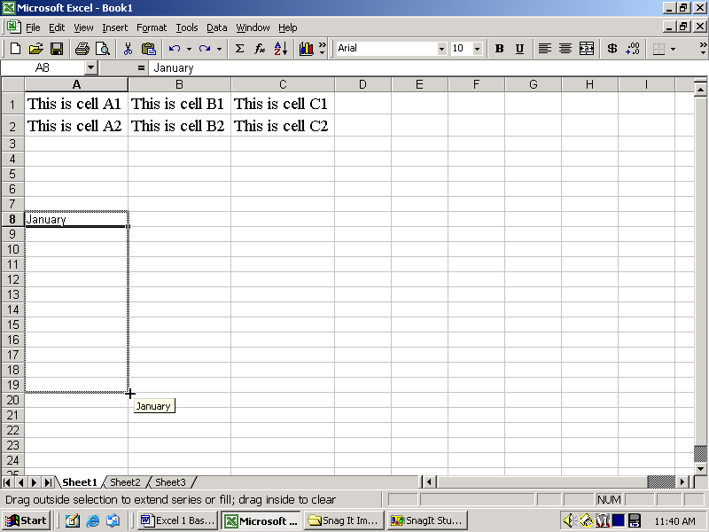

You can click and drag to complete a list.

CHANGE SIZE (columns and rows)

You will see this cursor when you put the mouse between the column labels.

You can click and drag to make the columns and rows bigger or smaller.

